**Before: ( No Upload File Button)**

**After: ( Upload File Button Added With Backend Logic)**

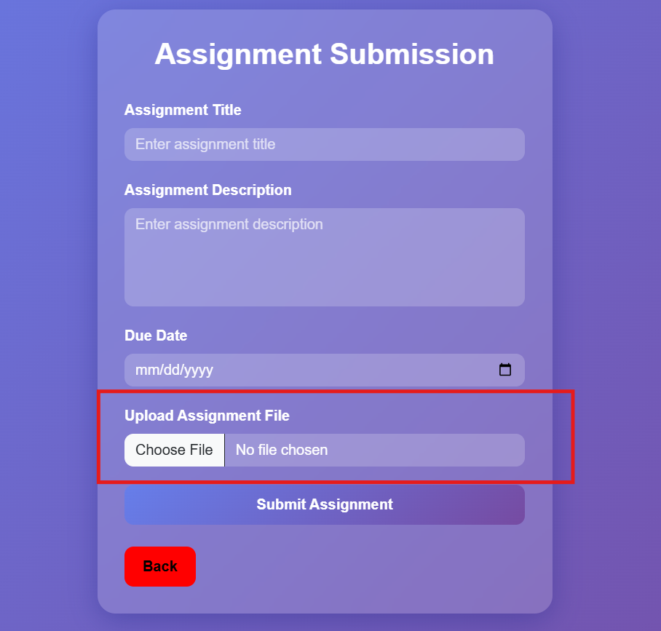

Backend Added:

